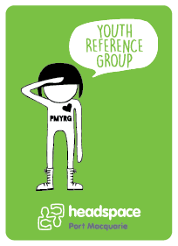

**Are you aged between 16 and 25, live in the Port Macquarie-Hastings area & have something to say about health, mental health or youth related issues?**

**WELL … WE WANT YOU!!!**

**Who can apply?**

**Anyone** aged 16- 25 who is interested in being involved in our local community.

**You may …**

feel passionate about and are interested in mental health issues**,**

be interested in healthcare for young people,

have had a personal experience, or know someone who

has/or had mental health issues

We are also keen to hear the voices of Indigenous young people, young people from different cultural backgrounds, young people from rural and remote areas, LGBTIQ young people and young people who have been homeless.

**What is the headspace Port Macquarie Youth Reference Group?**

The Youth Reference Group (YRG) aims to provide young people with the opportunity to be heard and be active around youth mental health and wellbeing.

**As a YRG member there are many benefits, experiences and opportunities for personal development. Such as:**

* Meet and work with other young people who are passionate about youth health
* Gain experience and references for your resume
* Training in youth advocacy, and other development opportunities
* Assisting on selection panels for headspace staff recruitment
* Leading a project in our local area
* Attending local community events including music festivals
* Website and social media consultation and development
* Resource development such as brochures, presentations, posters and radio ads
* Peer support and mentoring
* Media Spokesperson

**How do I get involved?**

It’s easy, complete an application form & email it to

[**julie.jamieson@each.com.au**](mailto:julie.jamieson@each.com.au)or drop it into our office located at 10-12 Short Street, Port Macquarie NSW 2444

**Want more info?**

Contact Jules on 6588 7308 or at [**julie.jamieson@each.com.au**](mailto:julie.jamieson@each.com.au)