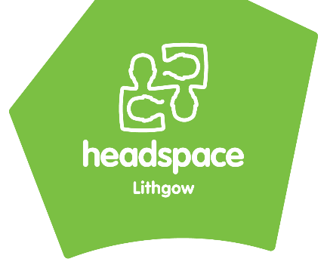
Self-Referral to headspace Lithgow
For yourself, family or friend…….

STOP Professional referrer Please use ‘professional referral form Thanks….
There are a few ways you can contact headspace Lithgow for an appointment. You are welcome to use the method that is most comfortable and convenient for you

Call us on the Phone at 6352 7600
Return this form via email: hs.Lithgow@marathonhealth.com.au
Come into the centre: 23 Main St, Lithgow, 2790
Do you believe this young person is at risk of harm to themselves or other people? ☐ Yes ☐ No
headspace is an early intervention and prevention service. If the young person is at risk of harm to themselves or to someone else, they are no suitable for headspace services. Please contact the mental health hotline on 1800 011 511 (24 hours) for appropriate services, take them to your nearest hospital, or call 000.
Young Person Details
First Name: |  |  |  |  | Last Name:
Date of Birth: |  | Age: |  |  | Sex:
Aboriginal | Torres Strait Islander |  |  | Both |  |  | Non-Indigenous
Address:
Suburb: |  |  |  |  |  | Postcode:
Phone Contact number:
What do you hope headspace Lithgow can help you with?
In addition, would you like to speak with someone who can help you with …
- Drug and Alcohol issues Yes / No / Maybe
- Vocational and Employment Issues Yes / No / Maybe
Can we sign you up to Spaces? Yes / No
headspace Spaces contain things you might find useful. Including, articles, videos, fact sheets, and free online and telephone support and counselling to young people 12 - 25 and their families and friends. It provides a safe, secure and anonymous place to talk. Password will be set as hsLithgow1
Have you previously seen another health practitioner? (e.g. Psychologist, Social Worker, Counsellor, Doctor)  Yes / No |  |  | Are you currently engaged with, or have previously seen another health practitioner? (e.g. Psychologist, Social Worker, Counsellor, Doctor)  Yes / No
If yes, Practitioner Name:
Supports:
If under 16 are your parents / carers aware of this referral? YES / NO (please circle)
Do you currently access any other support organisations? YES / NO (please circle)
Do you have a current Mental Health Care Plan? YES / NO (please circle)
Is there a Family Member / worker you would like us to speak to? YES / NO (please circle)
Their Name:
Contact number:
Relationship to you:
Referrer Details: (if a family member/carer/friend has completed this form)
Name:
Relationship to young person:
Contact number:
If not, the referral cannot be accepted. Get in touch and we’ll talk you through some other options.
Does the YP know about this referral? Yes ☐
Is the YP between 12 and 25 years of age? Yes ☐

