hERO Group Application Form

Completed applications can be dropped off to headspace Berri at 3, Riverview Drive Berri, email it to headspace@riverlandgp.org.au or fax it to 8582 3190.

Please phone headspace Berri on 8582 4422 if you have any questions. A headspace staff member will be in contact with you within 2 days of receiving your application! ☺

Personal Details:
Name: |  | DOB:
Town:
Contact No: | Email:

About You
- What would you like us to know about you?
(Example: I am 17 years old, I enjoy skateboarding and playing the piano and I have a dog named woof.)

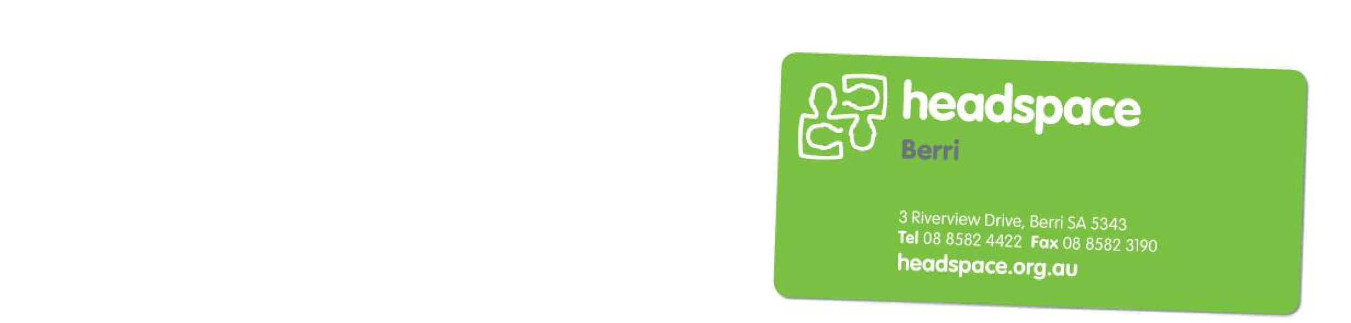
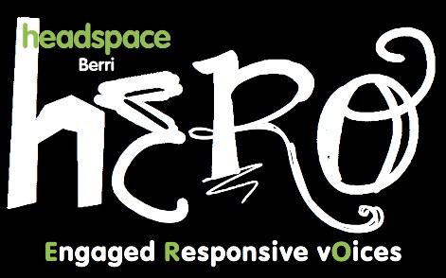
- What interested you about joining headspace Berri’s hERO group?

- What interests do you have? (Example: Social media, research, helping others, public speaking, health and wellbeing, project management, event planning, arts, sports etc.)

- What organisations are you involved with?
ABN 59 993 489 649 headspace National Youth Mental Health Foundation Ltd is funded by the Australian Government Department of Health and Ageing under the Youth Mental Health Initiative Program.

