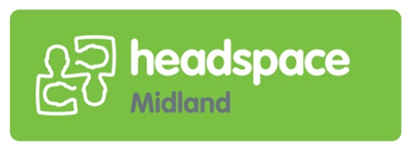

I am a:

 User of the service

 Parent/family (of user/client)

 Friend (of user/client)

 Other ……………………………………………………………….

Headspace staff members are always courteous towards you:

 Yes

 No

 If no, when/why? ………………………………………………………………………………………………………………………………..

The service is meeting my expectations:

 Yes

 No

 If no, when/why?

……………………………………………………………….………………………………………………………………

Which aspects of the service do you like the most? E.g. staff, counselling, workshops, the look of the service etc.

…………………………………………………………………………………………………………………………………………..………..……………………………………………………………………………………………………………………………...........  
…………………………………………………………………………………………………………………………………………..………..……………………………………………………………………………………………………………………………...........

Which aspects of the service could improve?

…………………………………………………………………………………………………………………………………………..….…….……..……………………………………………………………………………………………………………………………......  
…………………………………………………………………………………………………………………………………………..….……..……………………………………………………………………………………………………………………………............  
 *Your feedback is complete anonymous. If you would like a response, please leave your contact details on the back of this page.*

**Thankyou!**